USDA Foreign Agricultural Service
GAIN Report

Template Version 2.09

Global Agriculture Information Network

Required Report - public distribution
Date: 9/13/2005
GAIN Report Number: JA5060
JA9999
Japan
Fresh Deciduous Fruit
Annual
2005

Approved by:
Rachel Nelson
U.S. Embassy
Prepared by:
Kenzo Ito

Report Highlights:
U.S. exporters successfully increased their share of the Japanese table grape market, supplying 4,642 metric tons in 2004, up approximately 22 percent from the previous year and worth $10.81 million (CIF). Shipments from Chile were down approximately 13 percent in 2005 due to a short crop, according to Japanese traders. Japanese grape production this year is estimated to be 224,300 metric tons, up approximately 9 percent. After losing a series of U.S.-initiated WTO dispute settlement proceedings, Japan relaxed its phytosanitary restrictions against U.S. apples on August 25. Japan will also allow imports of California apples, in addition to those from Washington and Oregon. Japanese 2005 sand pear production is estimated to be 350,900 metric tons, up approximately 7 percent. Japan continues to ban imports of U.S. pears due to phytosanitary concerns.

Includes PSD Changes: Yes
Includes Trade Matrix: Yes
Annual Report
Tokyo [JA1]
[JA]

Table of Contents

The 2005 Domestic Table Grape Crop Expected to be Up 9 Percent 3
Japanese Imports of U.S. Table Grapes Up 22 Percent in 2004 4
Chilean Grape Sales Down 13 Percent in 2005 4
The 2005 Japanese Apple Production Expected to be Up 15 Percent 5
Japan Relaxes Measures on U.S. Apples 6
No Imports of U.S. Apples by Japan in 2004 6
The 2005 Japanese Crop of Sand Pears Expected to be Up 7 Percent 6
Japanese Western Pear Production Recovers in 2005 7
Japanese Import Duties on Fresh Apples and Table Grapes 7
Table 1 - The 2005 Crop Forecast of Table Grapes of 22 Major Prefectures 8
Table 2 - The 2005 Crop Forecast of Sand Pears of 27 Major Prefectures 8
Table 3 – Monthly Japanese Imports of Table Grapes by Country 9
PS&D Tables and Trade Matrices 10
Fresh Apple PS&D Table 10
Fresh Apple Export Trade Matrix 11
Fresh Apple Import Trade Matrix 12
Fresh Apple Wholesale Price Table 13
Fresh Pear PS&D Table 14
Fresh Pear Export Trade Matrix 15
Fresh Pear Import Trade Matrix 16
Fresh Pear Wholesale Price Table 17
Fresh Table Grape PS&D Table 18
Fresh Table Grape Export Trade Matrix 19
Fresh Table Grape Import Trade Matrix 20
Fresh Table Grape Wholesale Price Table 21

The 2005 Domestic Table Grape Crop Expected to be Up 9 Percent

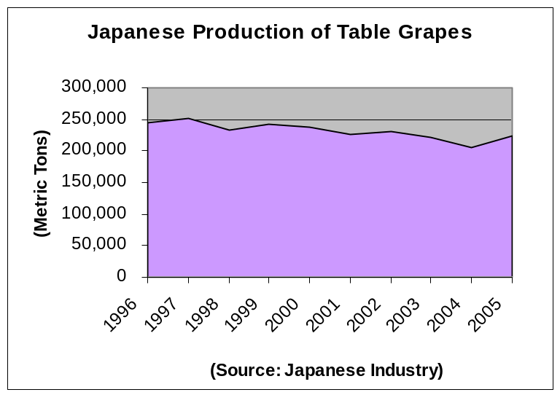 The 2005 Japanese production of table grapes approximately 224,300 metric tons, up approximately 9 percent from the previous season, according to industry sources. The growing region experienced fairly good weather this season, which brought high quality fruit. The crop experienced good fruit setting in the spring and large sized fruit. Fruit shipments to the market are expected to be delayed approximately 10 days, due to cooler temperatures in the early summer.

Japanese table grapes are primarily produced in mountain basin regions such as Yamanashi, Nagano and Yamagata, which produce approximately 26, 14 and 10 percent of the nation’s table grapes, respectively. The high temperatures during the day and cool temperatures at night, which are characteristic of these mountain basin regions, are suitable for table grape production. Japan produces various varieties of table grapes such as Kyoho, a large dark-purple grape which is the number one variety in terms of volume, followed by Delaware and Pione grapes. These three varieties compose over 65 percent of the domestic table grape supply. Production of relatively new varieties such as Koshu and Kaiji, which are similar to the U.S. Red Globe variety, increased marginally. Koshu and Kaiji are both old names for the Yamanashi region, approximately 100 miles northwest of Tokyo. The productions of Kyoho, Pione, Kaiji and Delaware varieties are expected to be up 13, 9, 5 and 4 percent, respectively, from the previous year, while the production of Koshu is expected to decline 3 percent, according to industry sources.

Japan’s total 2005 table grape harvest area is expected to be 19,200 hectares, a level similar to the previous season. The size of the Pione variety growing area is expected to increase 9 percent from the previous season, while the growing areas of Kyoho, Delaware, Koshu and Kaiji are declining 1, 2, 2 and 4 percent, respectively.

In late August, Delaware grapes were trading at $4.14 (455 yen) per kilogram at Tokyo Central Wholesale Market, and Kyoho and Kaiji grapes were trading at $8.60 (945 yen) and $6.69 (735 yen) per kilogram, respectively. Tokyo supermarkets sold a cluster of Kyoho grapes (approximately 400 grams) for $4.54 (499 yen) and a cluster of Delaware (approximately 100 gram) for $0.80 (88 yen) or a tray of four clusters for $3.18 (350 yen). Table grapes were individually packaged in clamshell type plastic containers.

* The exchange rate of 109.78 yen per dollar is based on the Nikkei News quote on August 23, 2005.

Japanese Imports of U.S. Table Grapes Up 22 Percent in 2004

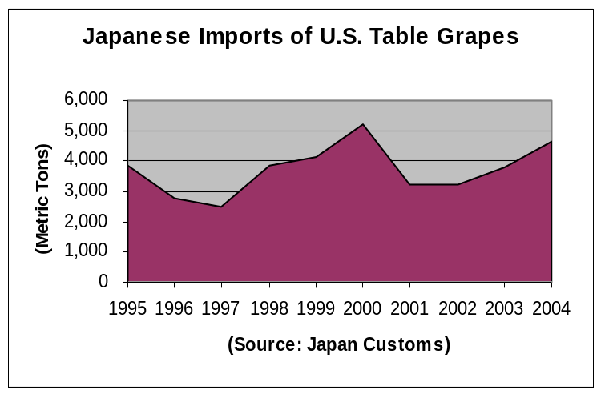 Japan imported 4,642 metric tons of U.S. table grapes in 2004, up approximately 22 percent from the previous year, valued at $10.81 million (CIF). The U.S. successfully increased its share of Japan’s imported table grape market from 28 percent in 2002 to 34 percent in 2004. California table grapes have a reputation among Japanese traders for high quality, high brix levels and a long shelf life.

U.S. table grapes have a fairly stable, established market
from August through January. Many Japanese traders discuss their marketing plans with U.S. growers before the start of the season, in order to maintain a stable market. Traders have been trying to market various varieties of table grapes from the United States, from red colored grapes to dark purple and light green colored ones. The Red Globe variety is by far the largest amount shipped to Japan from the United States, accounting for approximately 84 percent of the total U.S. table grape shipments to Japan in 2004. Crimson Seedless (red colored grapes) and Autumn Royal (dark purple grapes) are also important varieties from the United States, totaling approximately 6 and 4 percent of Japanese imports of U.S. table grapes, respectively. Yellowish green colored grapes such as Thomson Seedless and Princess are also important varieties from the United States.

Domestic grapes make up the majority of the Japanese table grape market with the new crop starting to be harvested in early July. Many Japanese retailers start sales of U.S. table grapes when domestic sales end in early October. However, this often creates a period between the end of domestic sales and the start of U.S. sales when no grapes are sold in retail stores in mid October. One Tokyo trader suggests that the U.S. increase exports table grapes a few weeks earlier, even before domestic grape sales are over, so that the momentum of consumer purchasing smoothly shifts to U.S. products from domestic ones.

California grape promotions started in August, including trade seminars and press events held by the California Table Grape Commission. This year’s promotions stressed the various health benefits of eating California table grapes. The Commission is also challenging Japanese consumers to eat California grapes with the skins on, since Japanese customarily peel skins before eating. Japanese retailers focus on California grape promotions in early December through the Christmas season using leaflets, posters and POP display materials.

Late August is a little too early in the season to see U.S. table grapes in Japanese retail stores, although one supermarket in Tokyo sold U.S. Flame Seedless grapes for $0.71 (78 yen) per 100 grams.

Chilean Grape Sales Down 13 Percent in 2005

Japanese imports of Chilean table grapes were down approximately 12.9 percent in the 2005 season to 7,939 metric tons, due to the short crop in Chile. Chile’s main grape growing region had poor weather and also experienced fruit fly damage, according to Tokyo traders. The total import value of Chilean grapes into Japan in 2005 was $11.66 million (CIF). Chile enjoys a counter seasonal advantage over Northern Hemisphere suppliers including the United States. Chile shipped fresh grapes to Japan from January to May 2005. Chile has improved the quality of its grapes over the years, but still finds some instability in quality due to the long transport period, according to Tokyo traders. Chile primarily shipped Red Globes and Thompson Seedless grapes to Japan. The new crop of Chilean Red Globes was trading at $36.43 (4,000 yen) for an 8.2-KG box in early February 2005 at the Tokyo Ohta Wholesale Market and the trading prices declined as shipments increased in April to $27.32 - $29.14 (3,000 – 3,200 yen). Thompson Seedless grapes were trading at $36.43 - $40.99 (4,000 - 4,500 yen) for a 7.3-KG box in April.

The 2005 Japanese Apple Production Expected to be Up 15 Percent

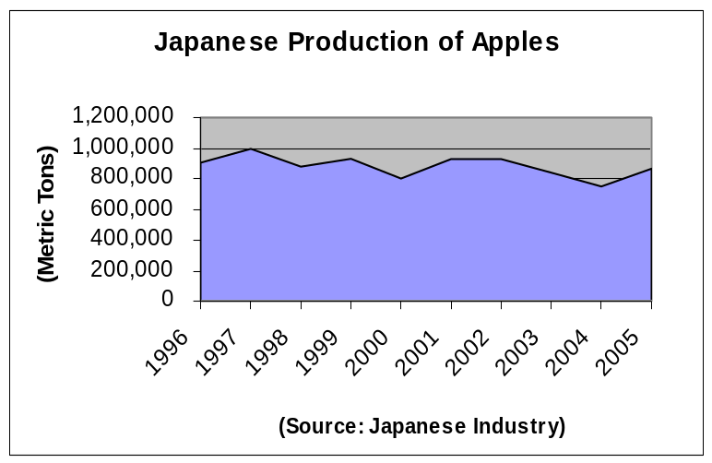 Japan’s apple production is estimated at 870,000 metric tons in 2005, up approximately 15 percent from the previous year, according to industry sources. This estimate is based on farm conditions as of May 1, 2005. Although this season’s crop experienced late flowering compared to the previous season, a fairly good harvest is expected since there was good fruit setting in the spring. Shipments to the market are expecting to be delayed approximately 10 days in relation to the previous year due to the later fruit maturity, according to industry sources. Since typhoons often hit Japan's apple region during harvest time, this year’s apple production figure is still hard to predict and may be less than expected.

Aomori prefecture expects a marginal decline in the output of Fuji apples this season, while growers expect a good crop of Tsugaru and Ohrin varieties. Aomori, approximately 400 miles North of Tokyo, is the nation’s apple capital, contributing approximately 53 percent of the nation’s total apple production. The Nagano region is also expecting a good crop with many large sized fruit due to fairly mild weather this season. Nagano, approximately 150 miles of Northwest of Tokyo, is another important region producing approximately 20 percent of nation’s apples.

In early August, the nation’s earliest apples, (Tsugaru variety) from Nagano, appeared in retail stores and were selling at premium prices. Japanese retailers mainly sell Tsugaru apples until early October and then they switch to late crop varieties such as Fuji apples. Fuji is Japan’s number one variety, which accounts for approximately 55 percent of the total production. Tsugaru, Jonagold and Ohrin are also important varieties, sharing approximately 12, 10 and 8 percent of Japan’s apple production, respectively. Approximately 16 percent or 145,000 metric tons of the 2005 crop apples are expected to go to processing, of which 125,000 metric tons go into juice and the rest go into jam and canning, according to industry sources.

In early September, Tsugaru apples from Nagano prefecture were sold at $1.16 (128 yen) for a medium sized apple or $4.54 (499 yen) for a tray of 4 medium sized apples in Tokyo’s supermarket. Medium sized (32 apples in 10-kilogram box) Tsugaru apples were trading at $28.69 - $34.43 (3,150 – 3,780 yen) for a 10-kilogram carton at Tokyo Ohta Wholesale Market.

Japan Relaxes Measures on U.S. Apples

After losing in a series of U.S.-initiated WTO dispute settlement proceedings, most recently in July, Japan officially removed most of its phytosanitary restrictions against U.S. apples on Aug 25th, including a buffer zone requirement and a requirement for MAFF inspectors to travel to the United States. Japan will also allow imports of California apples, in addition to those from Washington and Oregon. The two countries jointly informed the World Trade Organization that Japan's steps end what had been a decades-long dispute. The easing of the phytosanitary restrictions should allow U.S. apple exporters to sell their fruit in Japan for a lower price, but competition from domestic producers will be fierce.

No Imports of U.S. Apples by Japan in 2004

Japan opened its fresh apple market to U.S. apples in the summer of 1994 and sold U.S. apples nationwide in January 1995, for the first time in history. Japan imported 8,497 metric tons of U.S. Red and Golden Delicious apples in 1995; however, Japanese imports of U.S. apples declined dramatically in the following year to 841 metric tons. Japanese traders explained that the import decline was due to the high cost of U.S. apples and the fact that the U.S. was selling old varieties (Red and Golden Delicious). Japan approved the importation of five additional varieties of U.S. apples (Fuji, Gala, Granny Smith, Jonagold and Braeburn) in the summer of 1999. 211 and 322 metric tons of U.S. Gala and Fuji apples were sold in Japan in 2000 and 2001, respectively. There have been no imports of U.S. apples by Japan since the 2002 marketing year.

Japan imported 17 metric tons of fresh apples in 2004, of which 15 metric tons of Fuji apples were from Australia (Tasmania) and 2 metric tons of Fujis were from South Korea. Japanese consumers comment that Tasmanian Fuji apples are not so great in terms of size, color and flavor, according to Tokyo traders.

The 2005 Japanese Crop of Sand Pears Expected to be Up 7 Percent

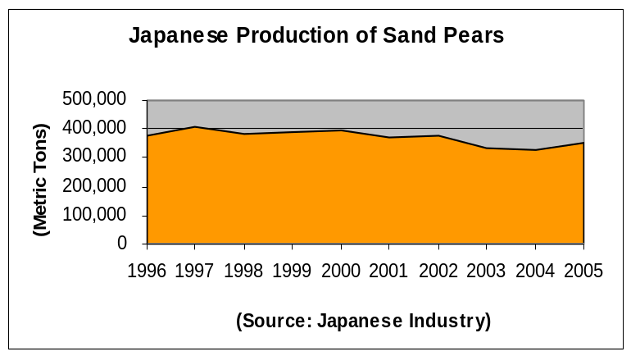 Japanese sand pear production in 2005 is estimated at 350,900 metric tons, up approximately 7 percent from the previous year, according to industry sources. Unlike the last season, there were no major typhoons that hit the growing regions this season and no significant damage to the crop was reported as of early September. Growing regions received fairly good weather in season, resulting in a good crop, although some regions experienced damage to their crop from a black spot disease. Fruit shipments to the market are expected to be delayed approximately 3 to 10 days in some regions compared to the previous year. The Kosui and Hosui varieties, which area large and extremely juicy and sweet, are Japan’s two major sand pear varieties. They comprise approximately 37 and 30 percent of the nation’s total pear production, respectively. The peak marketing of Kosui pears takes place in August and early September, while Hosui pears appear in the market later in the season. The Twentieth Century pear, which is also very juicy and sweet, is another important variety grown in Japan, comprising approximately 14 percent of total production. Kosui and Hosui varieties are light brown pears, while Twentieth Century is yellowish green pears. The growing area of Japanese sand pears in 2005 is estimated to be 15,200 hectares, down approximately 2 percent from the previous year, according to industry sources.

In early September, Kosui pears (size 24) were trading at $21.99 - $26.78 (2,415 – 2,940 yen) for 10-kilogram carton at the Tokyo Ohta Wholesale Market. Size 24 means that 24 of this sized fruit fit in a 10-kilogram carton. Tokyo supermarkets sold Kosui pears for $2.72 (299 yen) per tray of two large sized fruit or $5.28 (580 yen) per tray of four fruit.

Japanese Western Pear Production Recovers in 2005

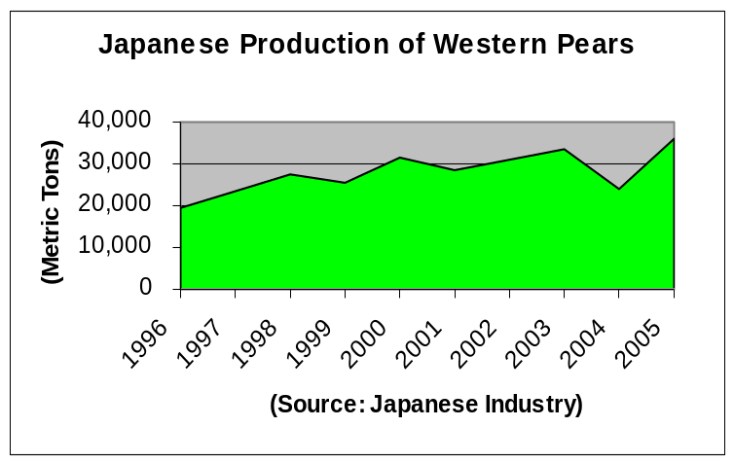Japan’s western pear production had significant typhoon damage in 2004, declining to 23,900 metric tons. Japanese industry sources expect recovery this season back to 36,000 metric tons. Japan’s western pear production, which is still minor compared to the nation’s sand pear output, experienced steady growth. La France pear, a yellowish green colored fruit, is the most commonly grown variety in Japan accounting for approximately 70 percent of nation’s western pear production. Bartlett pear is a relatively minor variety adding only 8 percent of the total production. Western pears will appear in the Japanese market in late fall. Japan continues to ban imports of U.S. pears due to phytosanitary concerns.

Japanese Import Duties on Fresh Apples and Table Grapes

These duties are not subject to further reductions. The applicable import duties are:

DESCRIPTION  TARIFF CODE (HS) |  | DUTY RATE
Fresh Apples  0808.10-000 |  | 17.0 %
Fresh Table Grapes  0806.10-000 | 3/1 – 10/31 | 17.0 %
Fresh Table Grapes  0806.10-000 | 11/1 – 2/28 | 7.8 %

All duties are charged on a CIF basis.

Table 1 - The 2005 Crop Forecast of Table Grapes of 22 Major Prefectures

Varieties | Harvest Area (HA) | Production (MT) | Changes from the Previous Year
Varieties | Harvest Area (HA) | Production (MT) | Harvest Area | Production
Total  (22 Prefectures) | 13,264 | 149,818 | No Changes | + 9 %
Delaware | 2,655 | 30,157 | - 2 % | + 4 %
Campbell | 550 | 6,517 | - 2 % | + 18 %
Kyoho | 4,715 | 49,869 | - 1 % | + 13 %
Pione | 1,624 | 18,414 | + 9 % | + 9 %
Bailey-A | 601 | 7,605 | - 2 % | - 2 %
Koshu | 484 | 7,137 | - 2 % | - 3 %
Kaiji | 332 | 5,218 | - 4 % | + 5 %
Other Varieties | 2303 | 24,901 | - 2 % | + 12 %
Source: Japanese Industry

Table 2 - The 2005 Crop Forecast of Sand Pears of 27 Major Prefectures

Varieties | Harvest Area (HA) | Production (MT) | Changes from the Previous Year
Varieties | Harvest Area (HA) | Production (MT) | Harvest Area | Production
Total  (29 Prefectures) | 13,027 | 289,899 | - 2 % | + 7 %
Kosui | 5,283 | 107,035 | - 2 % | + 3 %
Hosui | 3,276 | 87,663 | - 3 % | + 4 %
Niitaka | 986 | 27,218 | - 4 % | + 17 %
Twentieth Century | 1,865 | 35,221 | - 3 % | + 11 %
Other Varieties | 1,617 | 32,762 | - 2 % | + 7 %
Source: Japanese Industry

Table 3 – Monthly Japanese Imports of Table Grapes by Country
(Year: 2004 Unit: Metric Tons)

 | U.S. | Chile | New Zealand | Taiwan | Mexico | Total
January | 25 | 483 | 5 | 41 | 0 | 555
February | 0 | 875 | 3 | 19 | 0 | 898
March | 0 | 2,544 | 4 | 0 | 0 | 2,548
April | 0 | 3,506 | 1 | 0 | 0 | 3,508
May | 6 | 1,702 | 0 | 0 | 0 | 1,709
June | 2 | 0 | 0 | 0 | 0 | 2
July | 3 | 0 | 0 | 0 | 16 | 19
August | 26 | 0 | 0 | 0 | 0 | 26
September | 94 | 0 | 0 | 0 | 0 | 94
October | 891 | 0 | 0 | 0 | 0 | 891
November | 2,618 | 0 | 0 | 0 | 0 | 2,618
December | 975 | 6 | 1 | 21 | 0 | 1,003
Total | 4,642 | 9,118 | 14 | 81 | 16 | 13,873
(Source: Japan Customs)

PS&D Tables and Trade Matrices

Fresh Apple PS&D Table

PSD Table
Country | Japan
Commodity | Apples, Fresh |  |  |  | (HA)(1000 TREES)(MT)
 | 2003 | Revised | 2004 | Estimate | 2005 | Forecast
 | USDA Official [Old] | Post Estimate[New] | USDA Official [Old] | Post Estimate[New] | USDA Official [Old] | Post Estimate[New]
Market Year Begin |  | 07/2003 |  | 07/2004 |  | 07/2005
Area Planted | 44100 | 44100 | 43300 | 43700 | 0 | 43300
Area Harvested | 41600 | 41600 | 41300 | 41300 | 0 | 41000
Bearing Trees | 41600 | 41600 | 40800 | 41300 | 0 | 41000
Non-Bearing Trees | 2500 | 2500 | 2500 | 2400 | 0 | 2300
Total Trees | 44100 | 44100 | 43300 | 43700 | 0 | 43300
Commercial Production | 746900 | 746900 | 783200 | 667100 | 0 | 780000
Non-Comm. Production | 95200 | 95200 | 97900 | 87500 | 0 | 90000
TOTAL Production | 842100 | 842100 | 881100 | 754600 | 0 | 870000
TOTAL Imports | 0 | 0 | 0 | 17 | 0 | 0
TOTAL SUPPLY | 842100 | 842100 | 881100 | 754617 | 0 | 870000
Domestic Fresh Consump | 681468 | 681468 | 716100 | 598881 | 0 | 710000
Exports, Fresh Only | 15632 | 15632 | 20000 | 10736 | 0 | 15000
For Processing | 145000 | 145000 | 145000 | 145000 | 0 | 145000
Withdrawal From Market | 0 | 0 | 0 | 0 | 0 | 0
TOTAL UTILIZATION | 842100 | 842100 | 881100 | 754617 | 0 | 870000

Fresh Apple Export Trade Matrix

Export Trade Matrix
Country | Japan
Commodity | Apples, Fresh
Time Period | July-June | Units: | Metric Tons
Exports for: | 2003 |  | 2004
U.S. | 61 | U.S. | 55
Others |  | Others
Taiwan | 14947 | Taiwan | 10099
Hong Kong | 223 | Hong Kong | 199
Thailand | 210 | Thailand | 158
Indonesia | 79 | China | 115
Singapore | 41 | Singapore | 30
French Oceania | 20 | Indonesia | 30
Guam | 15 | French Oceania | 20
China | 11 | Russia | 13
Russia | 11 | Guam | 11
Total for Others | 15557 |  | 10675
Others not Listed | 14 |  | 6
Grand Total | 15632 |  | 10736

Fresh Apple Import Trade Matrix

Import Trade Matrix
Country | Japan
Commodity | Apples, Fresh
Time Period | July-June | Units: | Metric Tons
Imports for: | 2003 |  | 2004
U.S. | 0 | U.S. | 0
Others |  | Others
 |  | Australia | 15
 |  | South Korea | 2
Total for Others | 0 |  | 17
Others not Listed | 0 |  | 0
Grand Total | 0 |  | 17

Fresh Apple Wholesale Price Table

Prices Table
Country | Japan
Commodity | Apples, Fresh
Prices in | Yen | per uom | KG
Year | 2004 | 2005 | % Change
Jan | 238 | 281 | 18%
Feb | 243 | 265 | 9%
Mar | 256 | 273 | 7%
Apr | 264 | 297 | 13%
May | 281 | 335 | 19%
Jun | 299 | 354 | 18%
Jul | 326 |  | -100%
Aug | 292 |  | -100%
Sep | 252 |  | -100%
Oct | 295 |  | -100%
Nov | 283 |  | -100%
Dec | 294 |  | -100%
Exchange Rate | 109.78 | Local Currency/US $
Date of Quote | 8/23/2005 | MM/DD/YYYY

Fresh Pear PS&D Table

PSD Table
Country | Japan
Commodity | Pears, Fresh |  |  |  | (HA)(1000 TREES)(MT)
 | 2003 | Revised | 2004 | Estimate | 2005 | Forecast
 | USDA Official [Old] | Post Estimate[New] | USDA Official [Old] | Post Estimate[New] | USDA Official [Old] | Post Estimate[New]
Market Year Begin |  | 07/2003 |  | 07/2004 |  | 07/2005
Area Planted | 18440 | 18440 | 17980 | 18120 | 0 | 17800
Area Harvested | 17430 | 17430 | 17200 | 17230 | 0 | 16930
Bearing Trees | 4360 | 4360 | 4300 | 4310 | 0 | 4260
Non-Bearing Trees | 250 | 250 | 200 | 220 | 0 | 190
Total Trees | 4610 | 4610 | 4500 | 4530 | 0 | 4450
Commercial Production | 335100 | 335100 | 360800 | 321500 | 0 | 353100
Non-Comm. Production | 30700 | 30700 | 32600 | 30400 | 0 | 33900
TOTAL Production | 365800 | 365800 | 393400 | 351900 | 0 | 387000
TOTAL Imports | 96 | 96 | 100 | 266 | 0 | 100
TOTAL SUPPLY | 365896 | 365896 | 393500 | 352166 | 0 | 387100
Domestic Fresh Consump | 363561 | 363561 | 390650 | 349845 | 0 | 384750
Exports, Fresh Only | 1935 | 1935 | 2500 | 1971 | 0 | 2000
For Processing | 400 | 400 | 350 | 350 | 0 | 350
Withdrawal From Market | 0 | 0 | 0 | 0 | 0 | 0
TOTAL UTILIZATION | 365896 | 365896 | 393500 | 352166 | 0 | 387100

Fresh Pear Export Trade Matrix

Export Trade Matrix
Country | Japan
Commodity | Pears, Fresh
Time Period | July-June | Units: | Metric Tons
Exports for: | 2003 |  | 2004
U.S. | 403 | U.S. | 371
Others |  | Others
Taiwan | 742 | Taiwan | 1107
Hong Kong | 681 | Hong Kong | 398
Australia | 48 | China | 29
South Korea | 32 | Canada | 28
Guam | 9 | Australia | 17
Singapore | 8 | Singapore | 12
Thailand | 8 | Guam | 4
 |  | Thailand | 4
Total for Others | 1528 |  | 1599
Others not Listed | 4 |  | 1
Grand Total | 1935 |  | 1971

Fresh Pear Import Trade Matrix

Import Trade Matrix
Country | Japan
Commodity | Pears, Fresh
Time Period | July-June | Units: | Metric Tons
Imports for: | 2003 |  | 2004
U.S. | 0 | U.S. | 0
Others |  | Others
South Korea | 96 | South Korea | 266
Total for Others | 96 |  | 266
Others not Listed | 0 |  | 0
Grand Total | 96 |  | 266

Fresh Pear Wholesale Price Table

Prices Table
Country | Japan
Commodity | Pears, Fresh
Prices in | Yen | per uom | KG
Year | 2004 | 2005 | % Change
Jan | 250 | 327 | 31%
Feb | 249 | 308 | 24%
Mar | 220 | 272 | 24%
Apr | 173 | 197 | 14%
May | 157 | 564 | 259%
Jun | 1021 | 1227 | 20%
Jul | 447 |  | -100%
Aug | 276 |  | -100%
Sep | 224 |  | -100%
Oct | 287 |  | -100%
Nov | 289 |  | -100%
Dec | 402 |  | -100%
Exchange Rate | 109.78 | Local Currency/US $
Date of Quote | 8/23/2005 | MM/DD/YYYY

Fresh Table Grape PS&D Table

PSD Table
Country | Japan
Commodity | Grapes, Table, Fresh |  |  |  | (HA)(MT)
 | 2003 | Revised | 2004 | Estimate | 2005 | Forecast
 | USDA Official [Old] | Post Estimate[New] | USDA Official [Old] | Post Estimate[New] | USDA Official [Old] | Post Estimate[New]
Market Year Begin |  | 01/2004 |  | 01/2005 |  | 01/2006
Area Planted | 20300 | 20400 | 0 | 20400 | 0 | 20400
Area Harvested | 19300 | 19200 | 0 | 19200 | 0 | 19200
Commercial Production | 210000 | 187700 | 0 | 204600 | 0 | 205000
Non-Comm. Production | 15000 | 18100 | 0 | 19700 | 0 | 20000
TOTAL Production | 225000 | 205800 | 0 | 224300 | 0 | 225000
TOTAL Imports | 12000 | 13873 | 0 | 14000 | 0 | 14000
TOTAL SUPPLY | 237000 | 219673 | 0 | 238300 | 0 | 239000
Domestic Fresh Consump | 211950 | 194575 | 0 | 213190 | 0 | 213880
Exports, Fresh Only | 50 | 98 | 0 | 110 | 0 | 120
For Processing | 25000 | 25000 | 0 | 25000 | 0 | 25000
Withdrawal From Market | 0 | 0 | 0 | 0 | 0 | 0
TOTAL UTILIZATION | 237000 | 219673 | 0 | 238300 | 0 | 239000

Fresh Table Grape Export Trade Matrix

Export Trade Matrix
Country | Japan
Commodity | Grapes, Table, Fresh
Time Period | Jan.-Dec. | Units: | Metric Tons
Exports for: | 2003 |  | 2004
U.S. | 0 | U.S. | 0
Others |  | Others
Taiwan | 55 | Taiwan | 68
Hong Kong | 17 | Hong Kong | 26
 |  | Singapore | 3
Total for Others | 72 |  | 97
Others not Listed | 0 |  | 1
Grand Total | 72 |  | 98

Fresh Table Grape Import Trade Matrix

Import Trade Matrix
Country | Japan
Commodity | Grapes, Table, Fresh
Time Period | Jan.-Dec. | Units: | Metric Tons
Imports for: | 2003 |  | 2004
U.S. | 3806 | U.S. | 4642
Others |  | Others
Chile | 8800 | Chile | 9119
Taiwan | 112 | Taiwan | 81
Mexico | 17 | Mexico | 17
New Zealand | 15 | New Zealand | 14
Total for Others | 8944 |  | 9231
Others not Listed | 1 |  | 0
Grand Total | 12751 |  | 13873

Fresh Table Grape Wholesale Price Table

Prices Table
Country | Japan
Commodity | Grapes, Table, Fresh
Prices in | Yen | per uom | KG
Year | 2004 | 2005 | % Change
Jan | 517 | 649 | 26%
Feb | 470 | 614 | 31%
Mar | 662 | 836 | 26%
Apr | 2453 | 2789 | 14%
May | 1368 | 1605 | 17%
Jun | 1026 | 976 | -5%
Jul | 776 |  | -100%
Aug | 569 |  | -100%
Sep | 541 |  | -100%
Oct | 727 |  | -100%
Nov | 874 |  | -100%
Dec | 722 |  | -100%
Exchange Rate | 109.78 | Local Currency/US $
Date of Quote | 8/23/2005 | MM/DD/YYYY

